* 1. Implementation of additional features

The below are the screenshot for the scores without appending my features, these scores just reflect the accuracies with the baseline features.

**Accuracies on twitter_train.ner.pred(without features)**

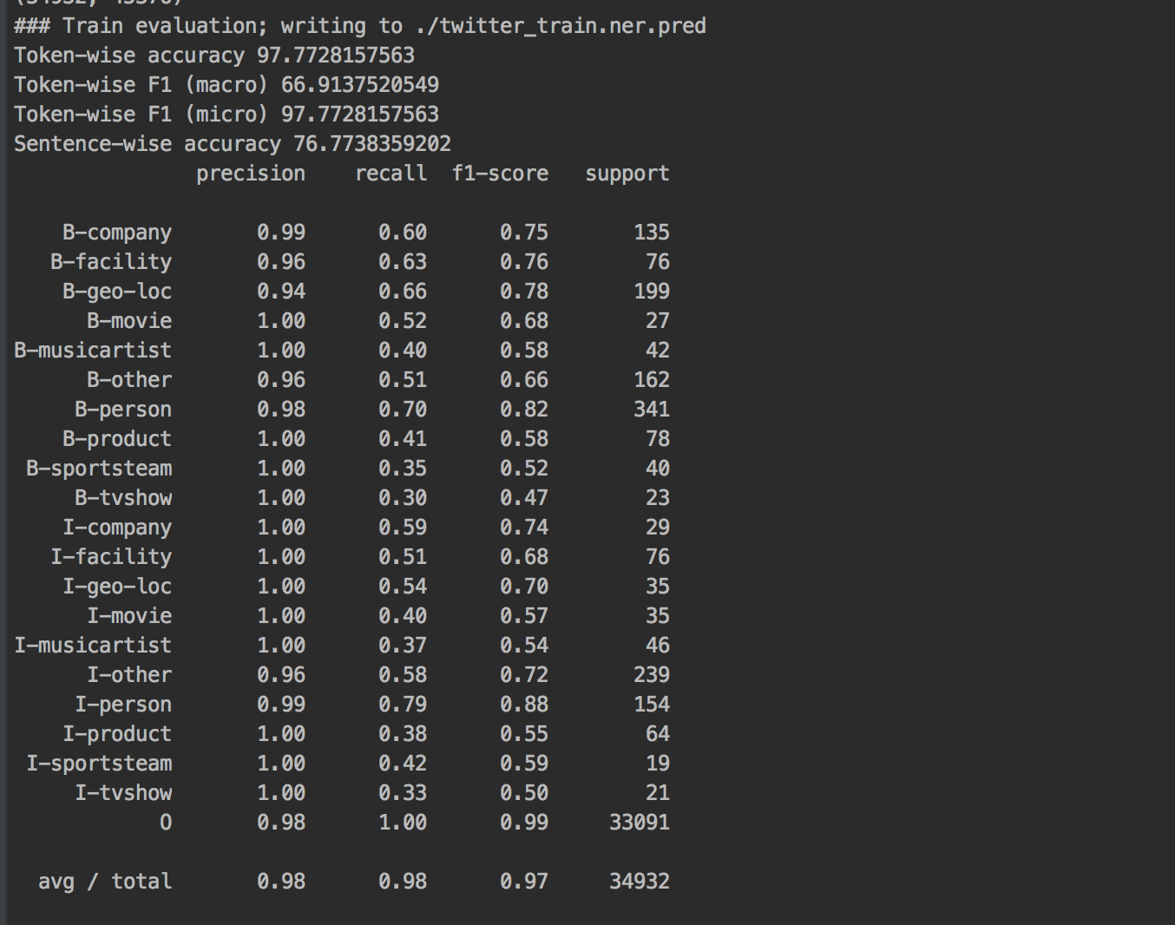

**Accuracies on twitter_train.ner.pred(with features)**

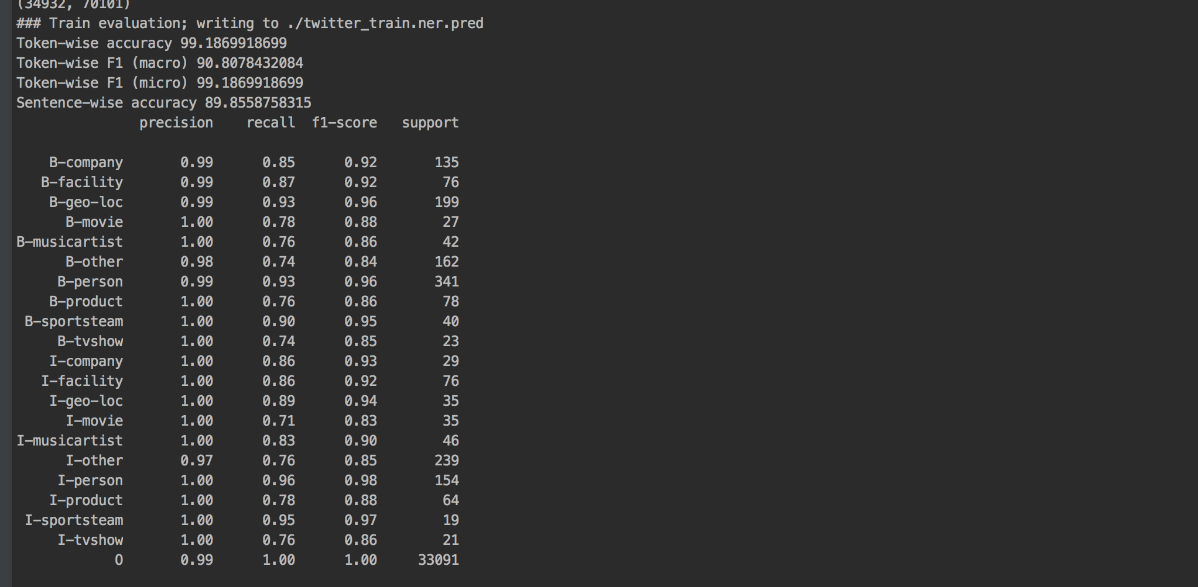

The above table shows difference in the accuracy of the twitter_train.ner.pred with baseline features and with features appended by me. Clearly, there is an increase in the token-wise accuracy by almost 2% which is good.

**twitter_dev.ner.pred (without features)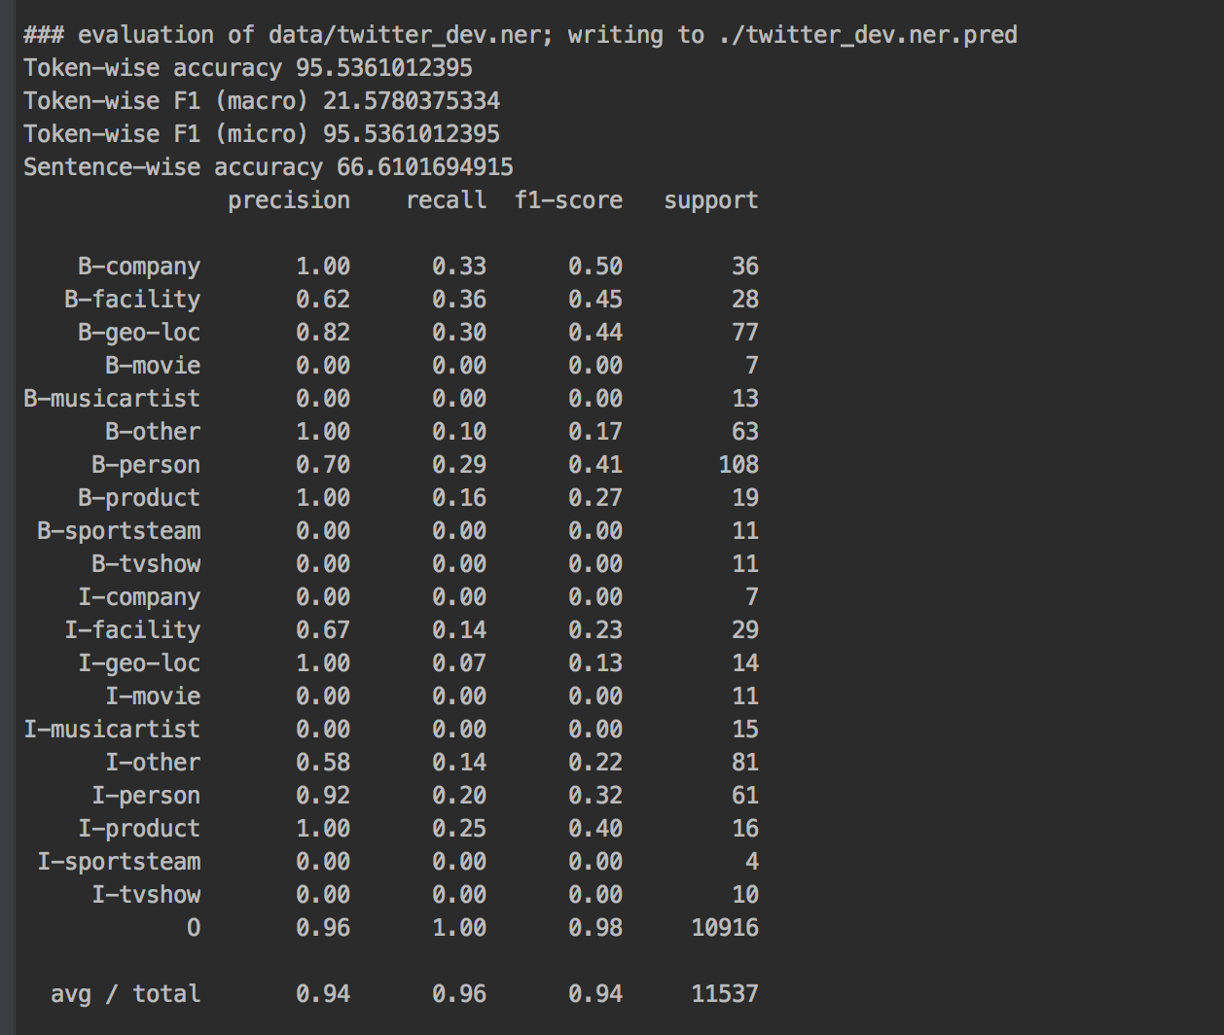CONLL evaluation for twitter_dev.ner.pred(without features)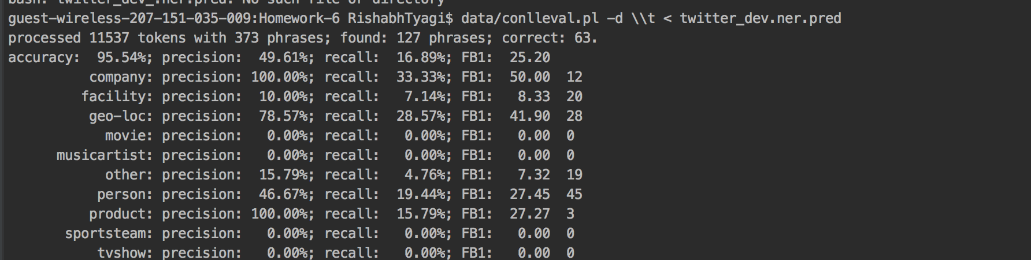twitter_dev.ner.pred (with features)** 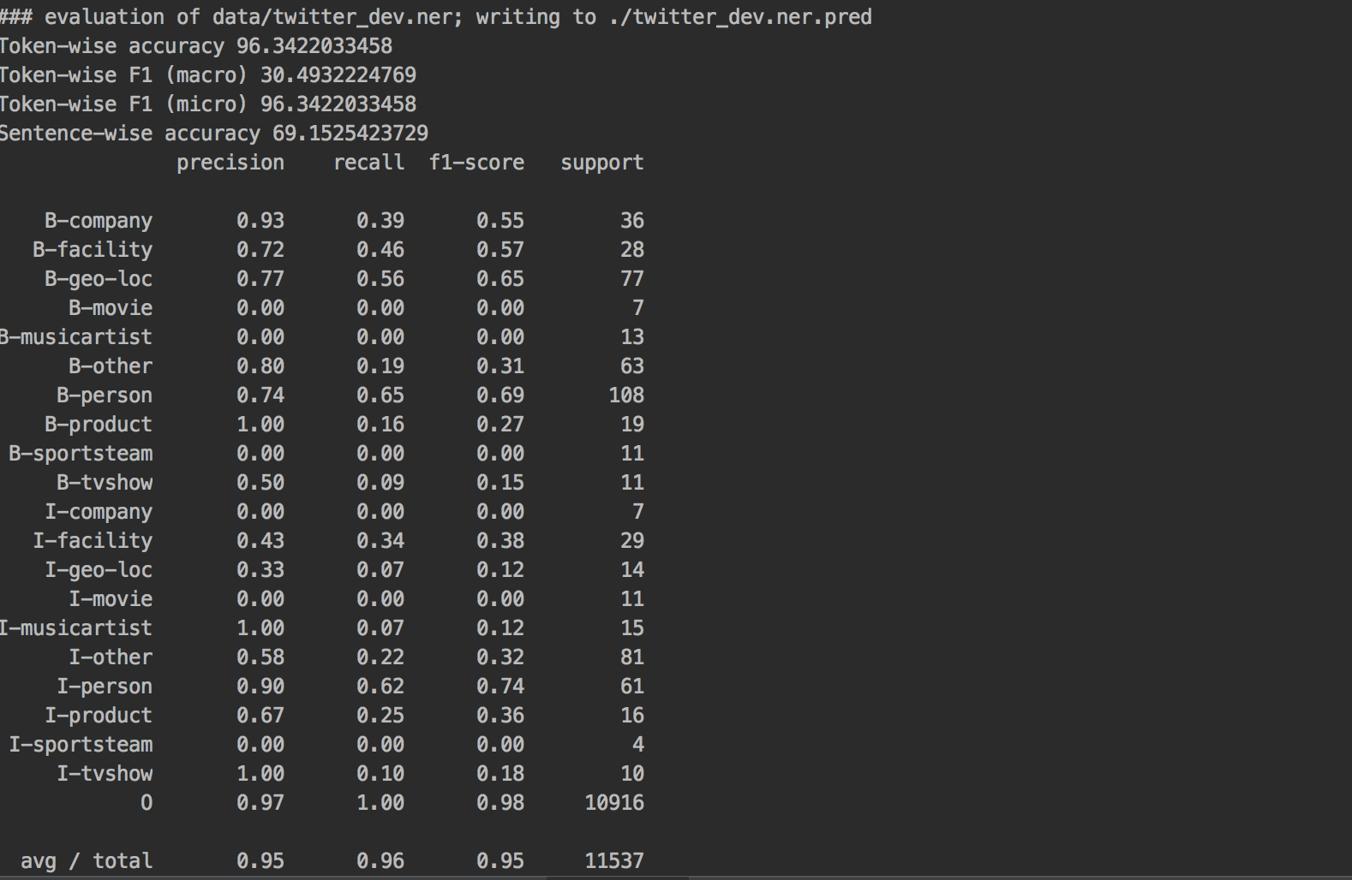There is increase in the accuracy by using extra features, this can be seen by increased accuracy by almost 9%, this shows that by using extra features such orthographic and gazetteer we can increase the accuracy of the logreg model.

**twitter_dev_test.ner.pred(without features)**

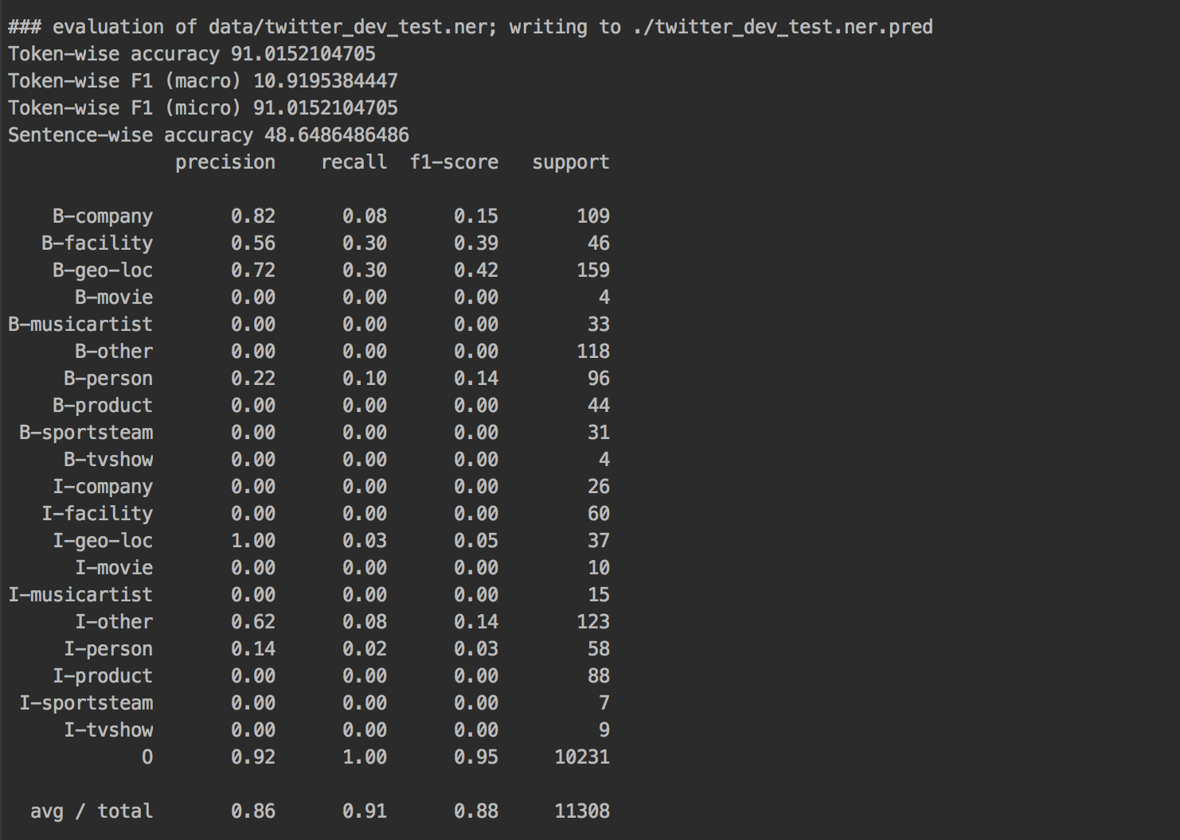

**CONLL evaluation for twitter_dev_test.ner.pred(without features)**

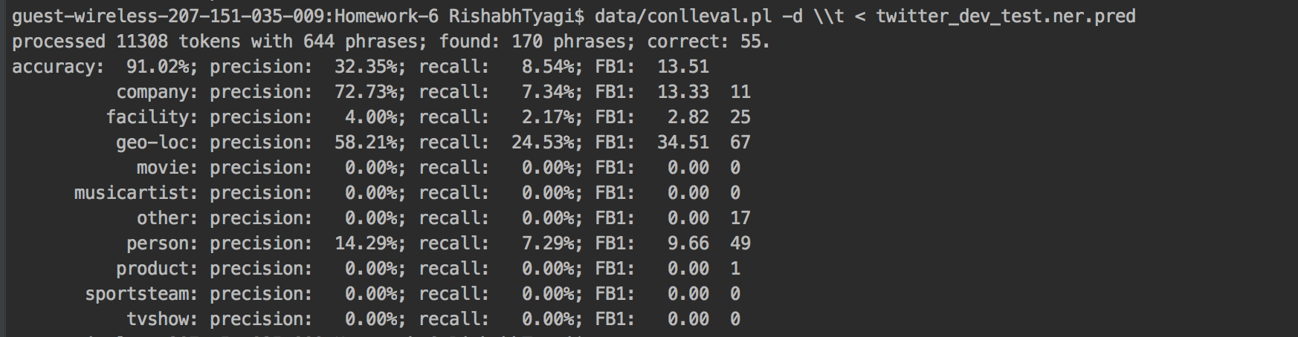**twitter_dev_test.ner.pred(with features)**

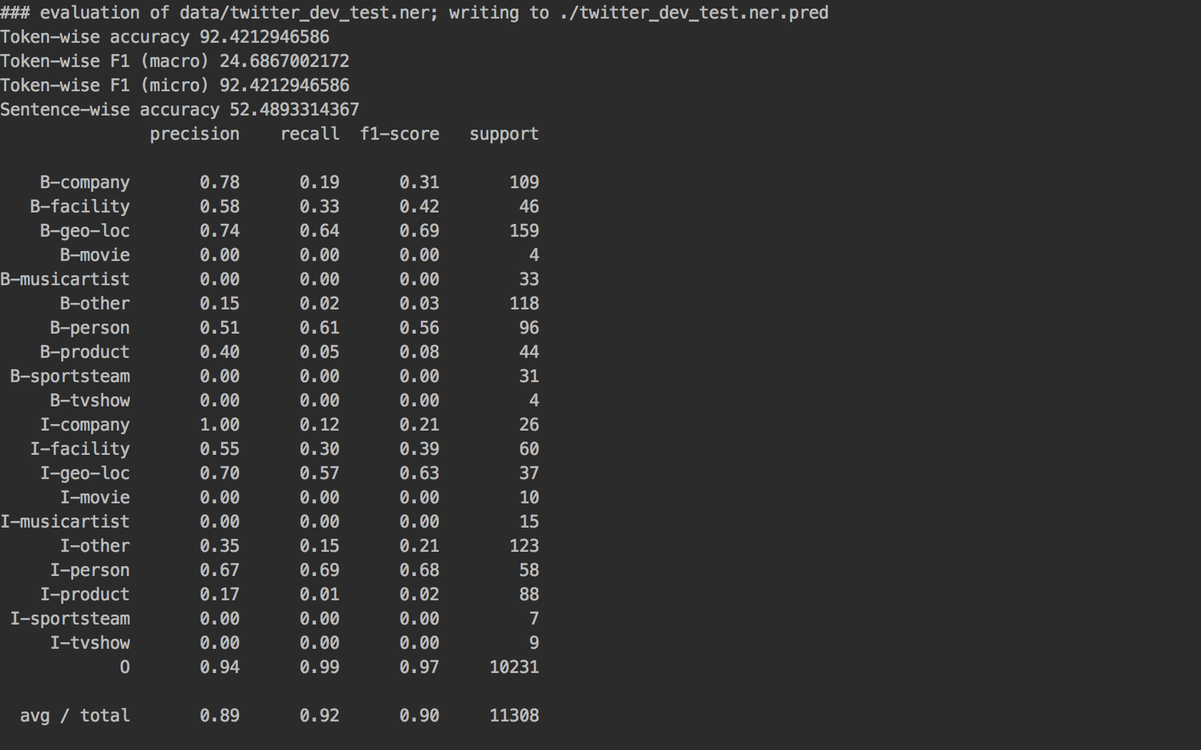

**CONLL evaluation for twitter_dev_test.ner.pred(with features)**

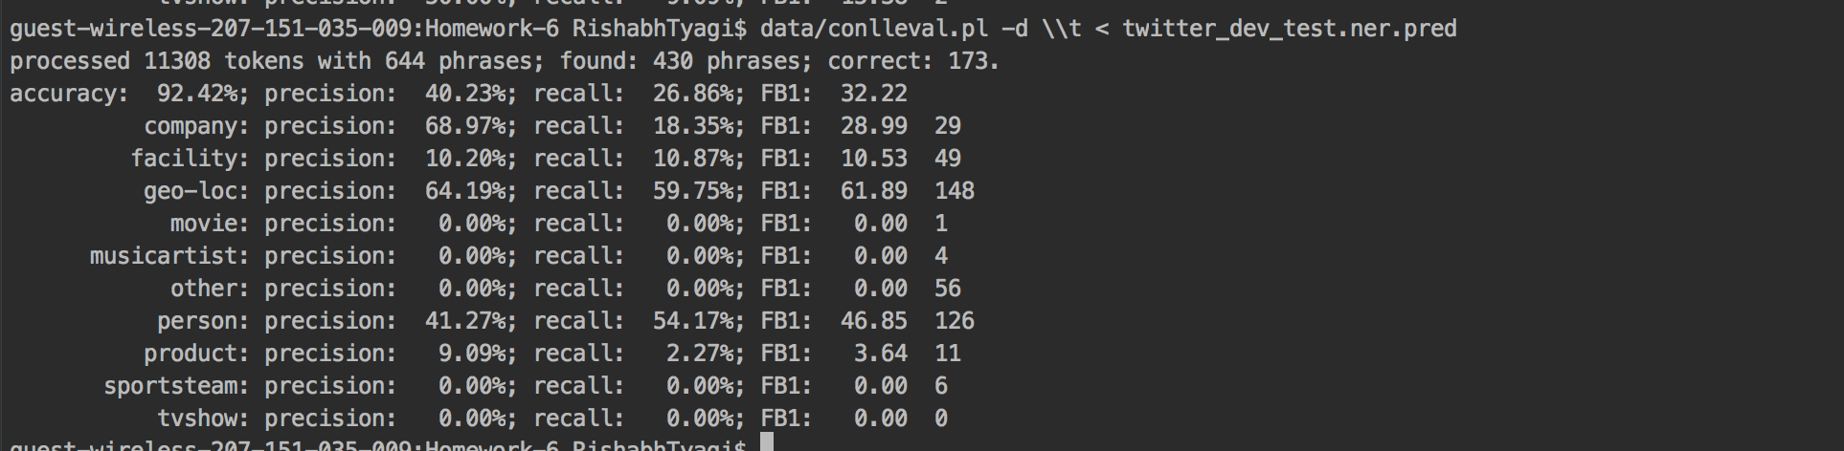

The same happens with the twitter_dev_test.ner.pred, we see that using additional features stated above results in increased accuracy of the model when using logistic regression.